**Design Specification**

Version: 0.2

April 22, 2016

Document ID: iTunes Music Player – NEU 210416

Author: Richard Thomas

**Table of Contents**

Version History ii

1.0 Introduction 1

2.0 System Architecture 2

3.0 Packages 3

3.1 Model Packages 3

3.2 User Interface Packages 3

4.0 Class Diagrams 4

4.1 Music Collection 4

4.2 Music Codecs 5

4.3 Play Music Commands 6

4.4 Streaming Services 7

4.5 Browse Music 7

4.6 Music Player Preferences 8

4.7 iTunes Store Synchronisation 9

4.8 Album User Interface 10

5.0 Interaction Diagrams 11

5.1 Play Track in Album Sequence Diagram (UC-5.2) 11

6.0 State Machine Diagrams 13

6.1 13

7.0 Summary 14

8.0 References 15

# Version History

|  |  |  |
| --- | --- | --- |
| **Issue** | **Date** | **Change** |
| 0.1 | 21/04/2016 | Initial model created in class. |
| 0.2 | 22/04/2016 | Revised model to better reflect MVC pattern. |

# Introduction

Sample design model for the music player application on an Apple® device such as an iPhone® or iPad®.

# System Architecture

The architecture for the iTunes® music player is based on the Model-View-Controller (MVC) design pattern, with the addition of internal control classes to coordinate the model’s internal behaviour.

The diagram below provides an overview of the software architecture. The Music Player Design frame shows the overall design structure. The internal rectangle, labelled *Behavioural & Model Layer*, encapsulates the model behaviour consisting of MVC model classes and UML control classes. The diamond, labelled *View & Contoller Layer*, encapsulates the user interface behaviour in view and controller classes. The *iTunes Store Synchronisation* package encapsulates the behaviour of interacting with the iTunes Store®.

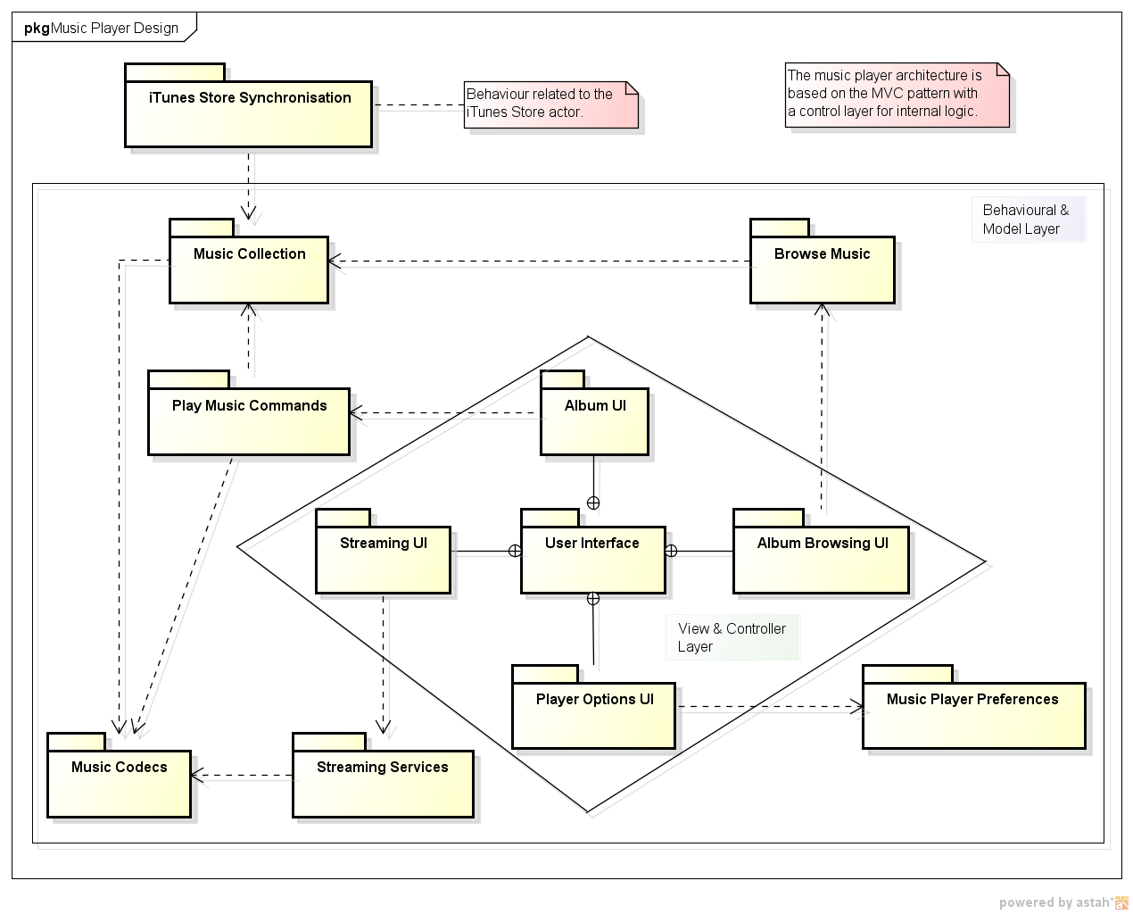

# Packages

## 3.1 Model Packages

|  |  |
| --- | --- |
| **Package Name** | **Description** |
| Music Collection | The model of the music collection with albums, tracks, playlists and associated track and album information. |
| Music Codecs | The music decoding interface with the codec packages that perform the decoding. |
| Play Music Commands | The strategy pattern is used to implement the music controls commands. |
| Streaming Services | Provides access to streaming music programmes. |
| Browse Music | The strategy pattern is used to implement the behaviour to browse, and search for, music according to different parameters. |
| Music Player Preferences | The strategy pattern is used to implement the music player and music playback options. |
| iTunes Store Synchronisation | Implements the behaviour of interacting with the iTunes store and to upload music preference information. |

## 3.2 User Interface Packages

|  |  |
| --- | --- |
| **Package Name** | **Description** |
| User Interface | The base package for the music player’s user interface. |
| Album UI | Provides the views and controllers used to display albums, their tracks and enable interaction with the album and tracks. |
| Streaming UI | Provides the view and controllers used to select and a music stream and interact with the playback of the stream. |
| Album Browsing UI | Provides the views and controllers used to browse music in the player. |
| Player Options UI | Provies the views and controllers used to adjust the player’s preferences and playback options. |

# Class Diagrams

## 4.1 Music Collection

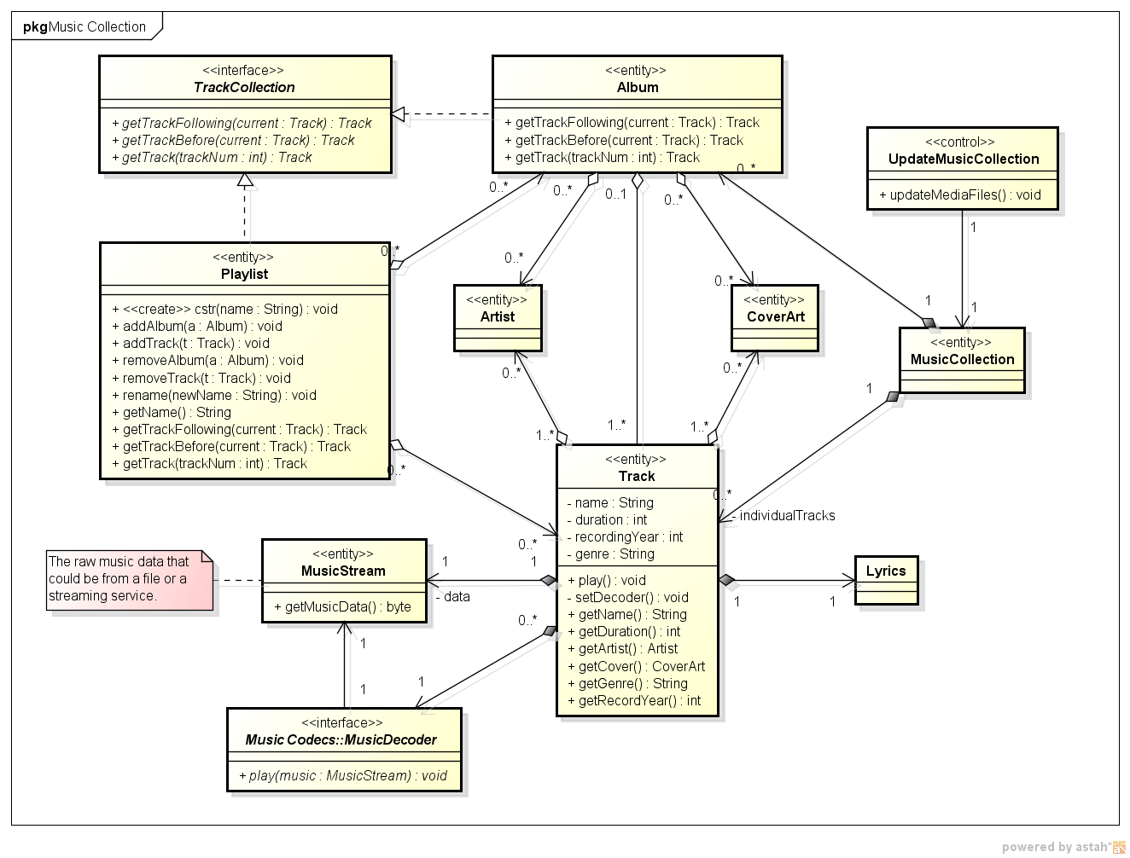

## 4.2 Music Codecs

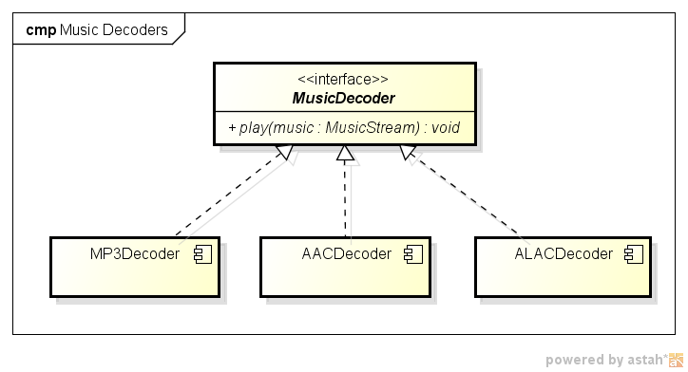

## 4.3 Play Music Commands

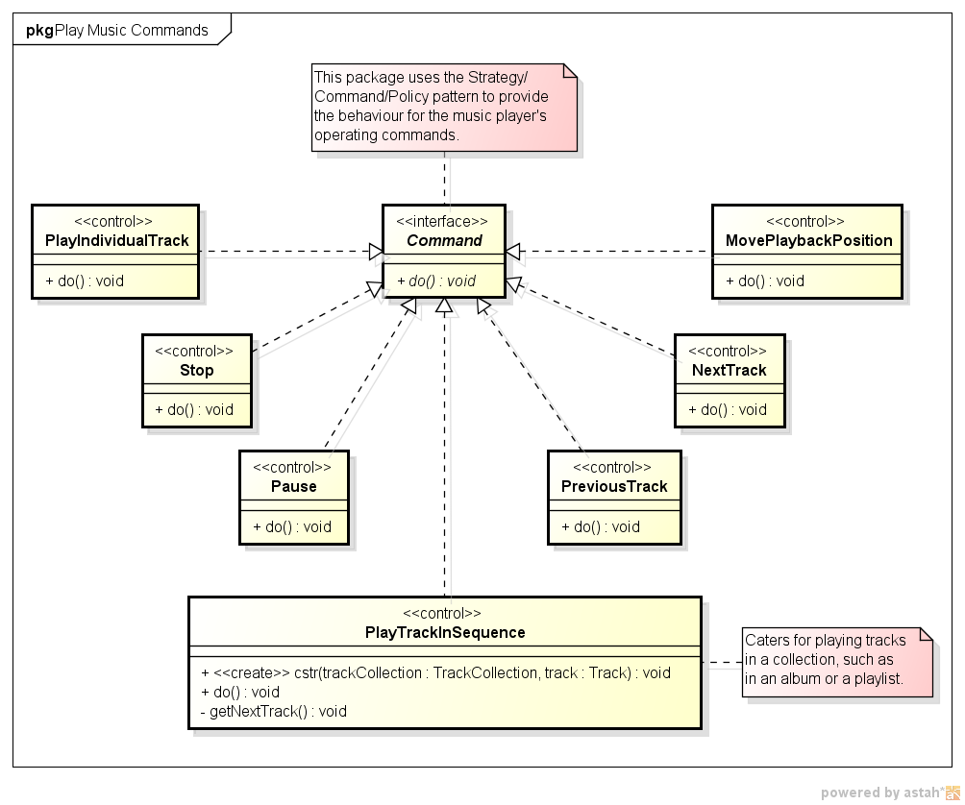

## 4.4 Streaming Services

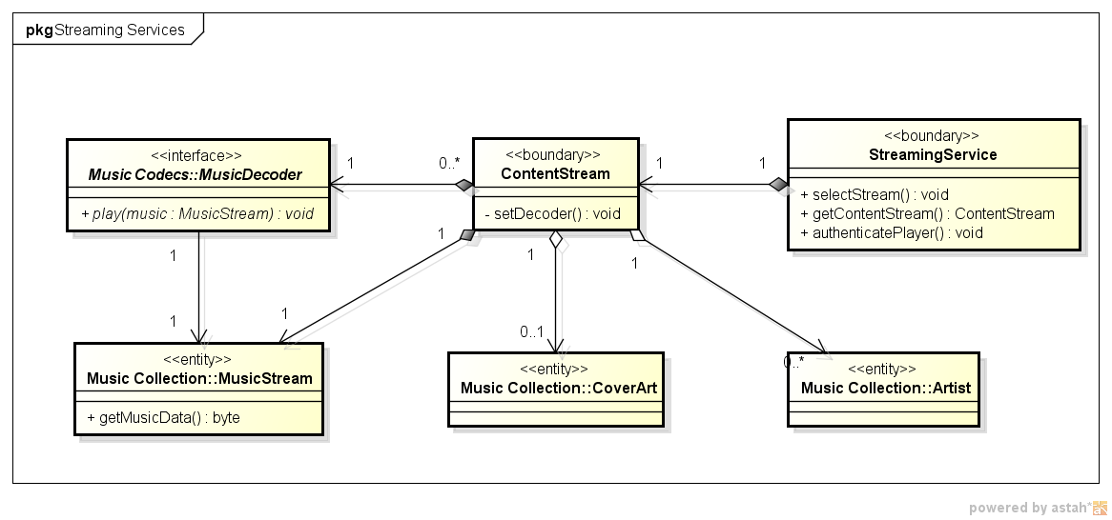

## 4.5 Browse Music

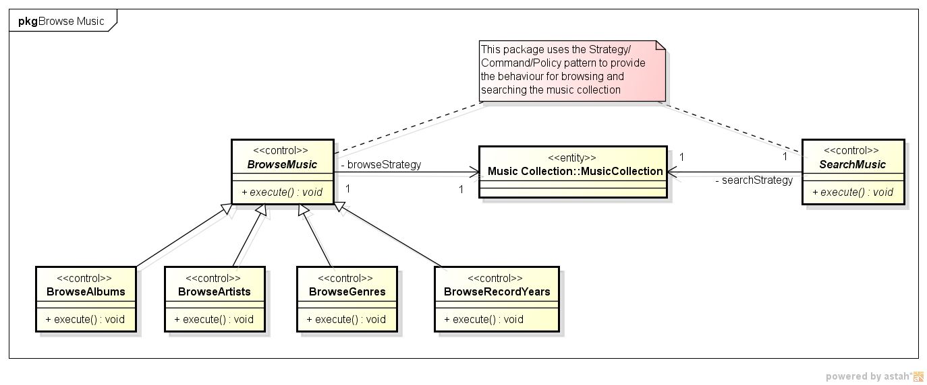

## 4.6 Music Player Preferences

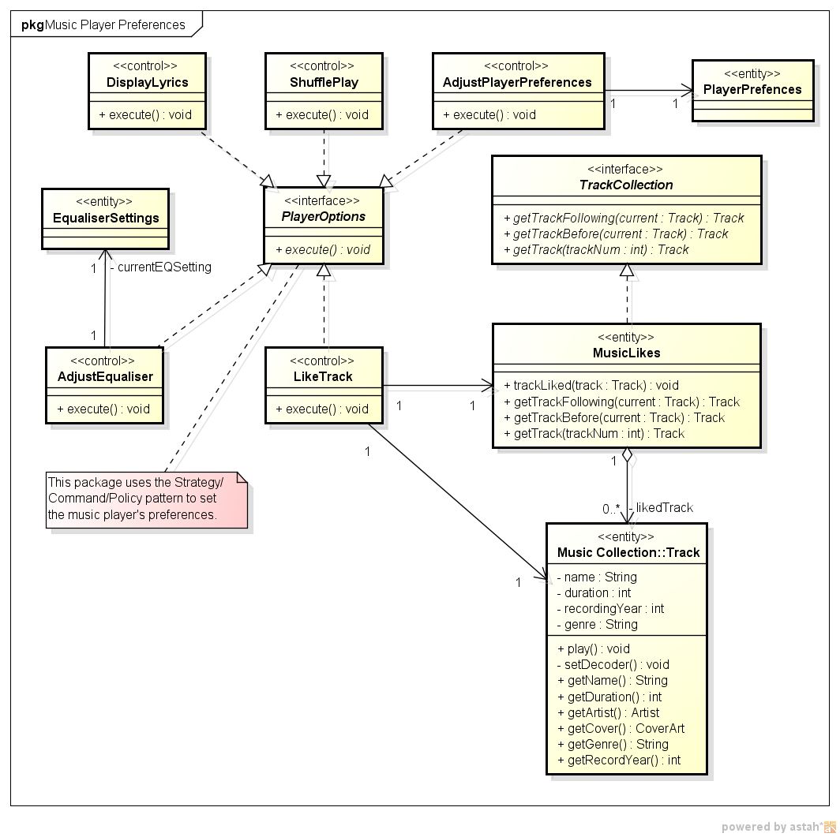

## 4.7 iTunes Store Synchronisation

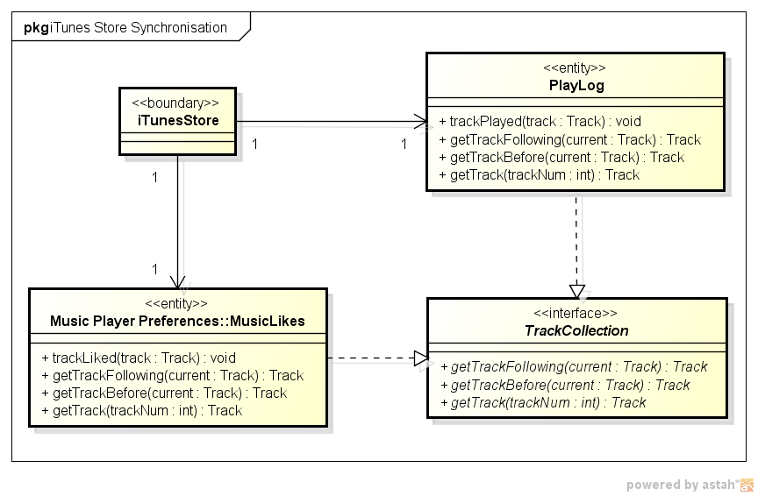

## 4.8 Album User Interface

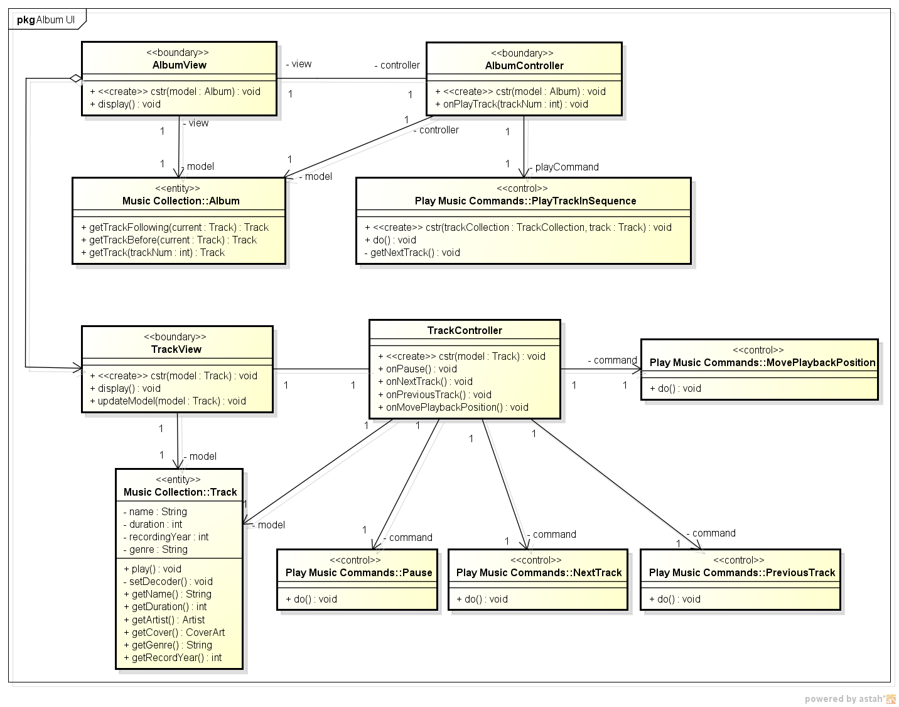

# 5.0 Interaction Diagrams

## 5.1 Play Track in Album Sequence Diagram (UC-5.2)

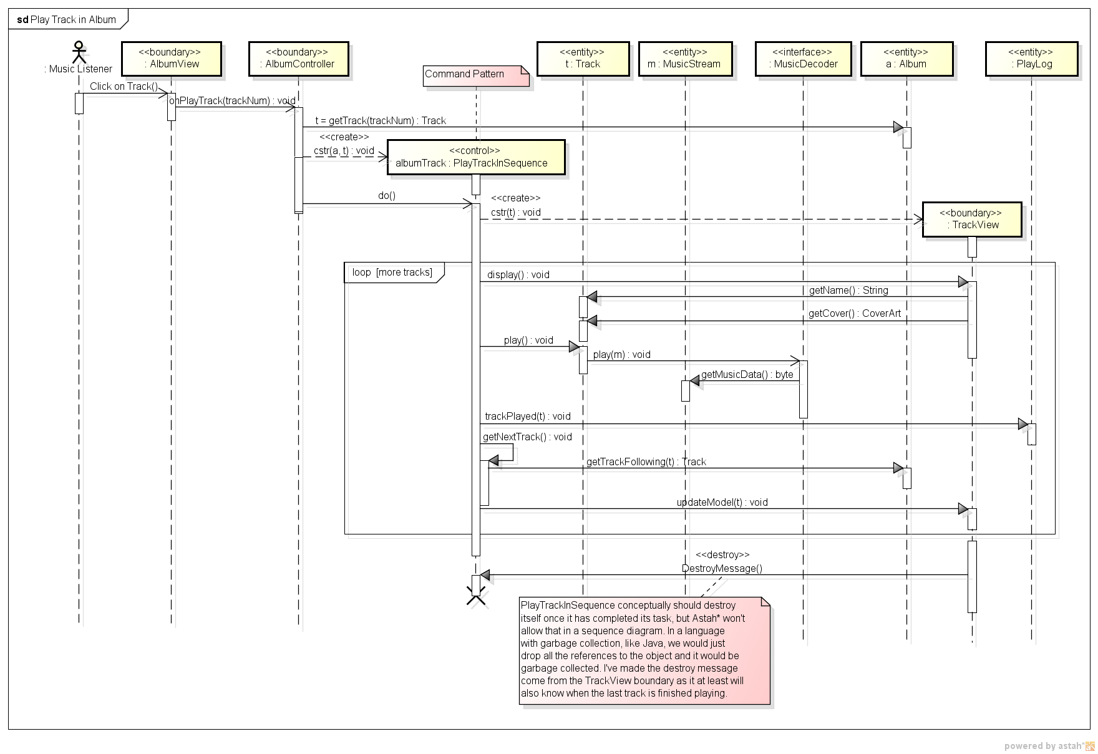

# State Machine Diagrams

## 6.1

# Summary

The design described in this document provides the details of the implementation structure for the music player on an Apple® device, such as an iPhone® or iPad®. It uses the MVC pattern to provide a clean separation between the user interface and the application’s behaviour. The strategy pattern is used to provide most of the internal application behaviour, with each strategy being triggered from an MVC controller.

# References

Apple iPod Touch Technical Specifications. http://www.apple.com/ipod-touch/specs/ [Accessed: 14/04/2016].